Team20 Phase 4 Report

# System Functionality

1. Suggesting candidates who meet the user’s criteria;
2. Showing an author’s profile, which include his/her associated school, experience as a program committee member, and bibliography;
3. Helping the user create and maintain his/her own list of candidates;
4. Comparing the list of candidates of the user.

# New Features Added Since Phase 3

1. Original main page and result page are now merged into a single page;
2. Inputting special characters is now prohibited;
3. Message boxes added for warnings and progress;
4. Charts added for comparing candidates;
5. Drag-and-drop feature added to the page displaying an author’s profile;
6. Two new kind of information used: associated school and committee experience;
7. Bibliography table now displays more information of a publication and author details;

# Refactoring

1. Two helper classes (TableColumnAdder & UIElementFixer) for the user interface component are extracted;
2. UserInterface.java renamed ConcreteUserInterface.java;
3. Two interfaces that are intended to be used for the user interface are moved under a package named UserInterface.interfaces;

# Design Pattern Applied

1. Design Pattern Singleton applied onto classes MainPage and QueryEngine

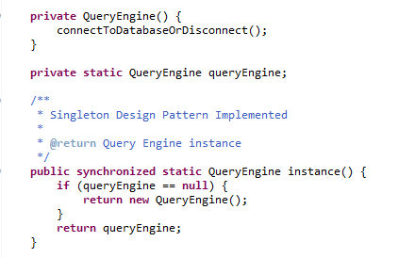

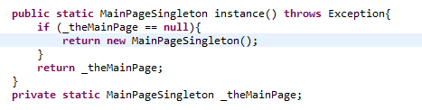

# Each Screen Visual Share and Function Details Explanation



1. This is our system main screen. Left Part is user’s criteria part. Right Part is result of criteria.
2. Button Search can get the search result. If nothing for criteria, then we get all the authors and their publications.
3. Button Clear can clean the criteria of the Left Part which allow user to re-fill.
4. Button My Favorite Author can link to Candidate Page
5. User can search the publications by type in either all or part or single of these: Keywords in Title, Conference/Journals related the publication, a publication year, the authors who’s total number publication more than certain number, and whether the author was served as any committee within certain years.



1. Right Part user can search interested information of one publication.
2. Button View Author Pages allowed user to watch details of the author he/she has interested.
3. Button Compare Candidates will link to Compare Page



1. In the Author Profile Page, user can check all this author’s publication and their details such as type of this publication, title of it, year of published, publisher, book title, journal if has, volume, etc.
2. In the Author Profile Page, user can view this author’s experience in committees which include in which year, he attend which committee and was what kind of role.
3. In the Author Profile Page, user can click button Add to Candidate list to add this author into Candidate Page.
4. In the Author Profile Page, user can click button Find Similar Author to get author list who write same publication with him/her, or who attend the same committee with him/her at the same year.
5. In the Author Profile page, user can drag this author name to the top right corner can quick add this author into Candidate List/Page.



1. In the Compare Page, user can see all the candidate which he selected from the Author Page and these author’s Committee Role.
2. In the Compare Page, user can see these authors distribution of their number of publication. For instance, from this page, use can know author Hanne Rils Nielson wrote more publications.
3. In the Compare Page, user can select one author name from the left list and click button View Author Pie Chart, then a new pie chart appears and shows the distribution on publication years of an author. During this pie chart, user can know on which this author most work focused and whether his working interrupted or not.
4. In the Similar Author Page, user can check other user’s name and details.
5. In the Candidate Page, user can view all the authors name who the user added by page navigation.
6. In the Candidate Page, user can view single or multiple remove the author names.